Documentation

Table of Contents

Images 2

Assets Used 5

Sound: 6

References 8

# Images

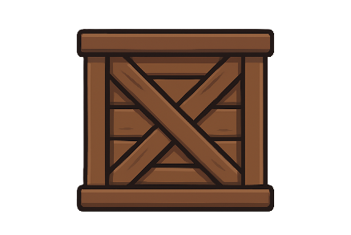

Figure 1: ChatGPT. [SA]. *Crate Sprite*. (ChatGPT, 2025)



Figure 2: ChatGPT. [SA]. *Nuclear Reactor Sprite*. (ChatGPT, 2025)



Figure 3: ChatGPT. [SA]. *Magic Barrier Sprite*. (ChatGPT, 2025)

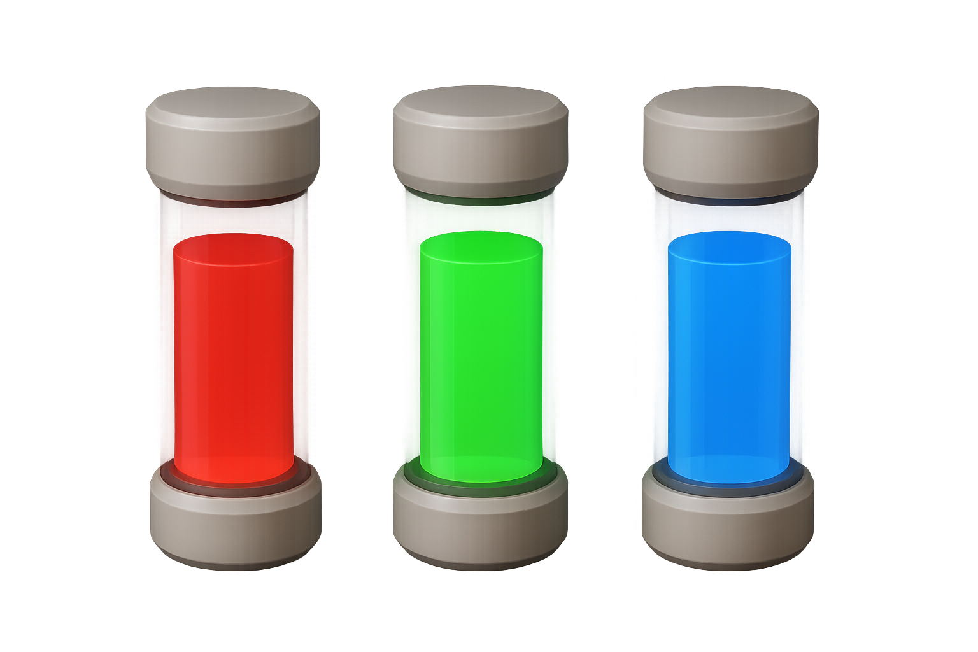

Figure 4: ChatGPT. [SA]. *Nuclear Reactor Rods Sprite*. (ChatGPT, 2025)

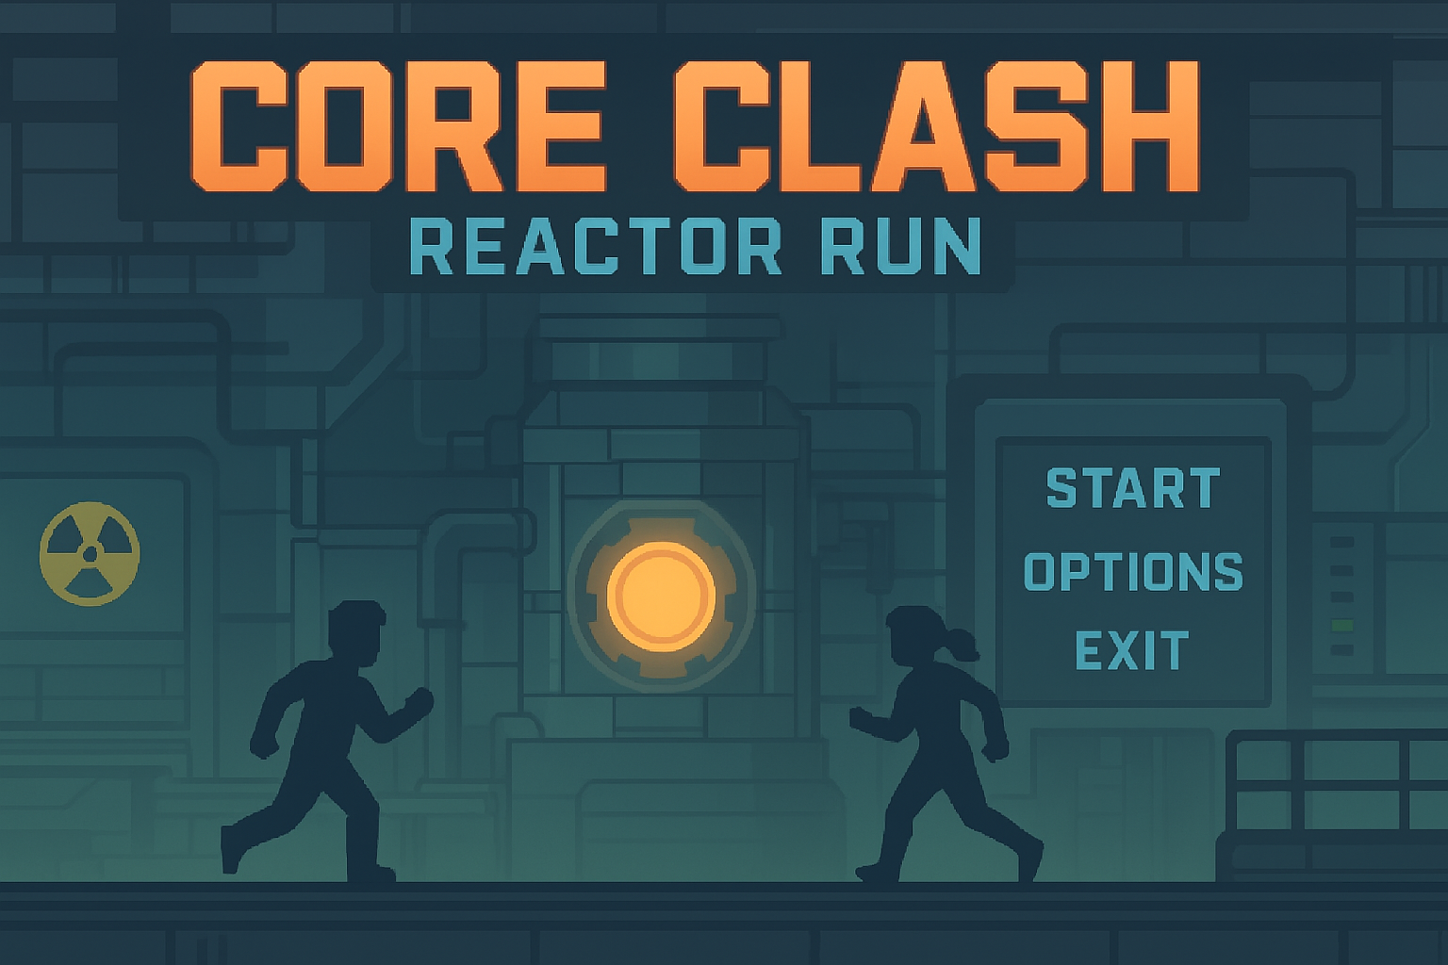

Figure 5: ChatGPT. [SA]. *Main Menu Background image*. (ChatGPT, 2025)



Figure 6: ChatGPT. [SA]. *Demon Sprite*. (ChatGPT, 2025)



Figure 7: ChatGPT. [SA]. *Missile Sprite*. (ChatGPT, 2025)



Figure 8: ChatGPT. [SA]. *Sabotage Coin Sprite*. (ChatGPT, 2025)

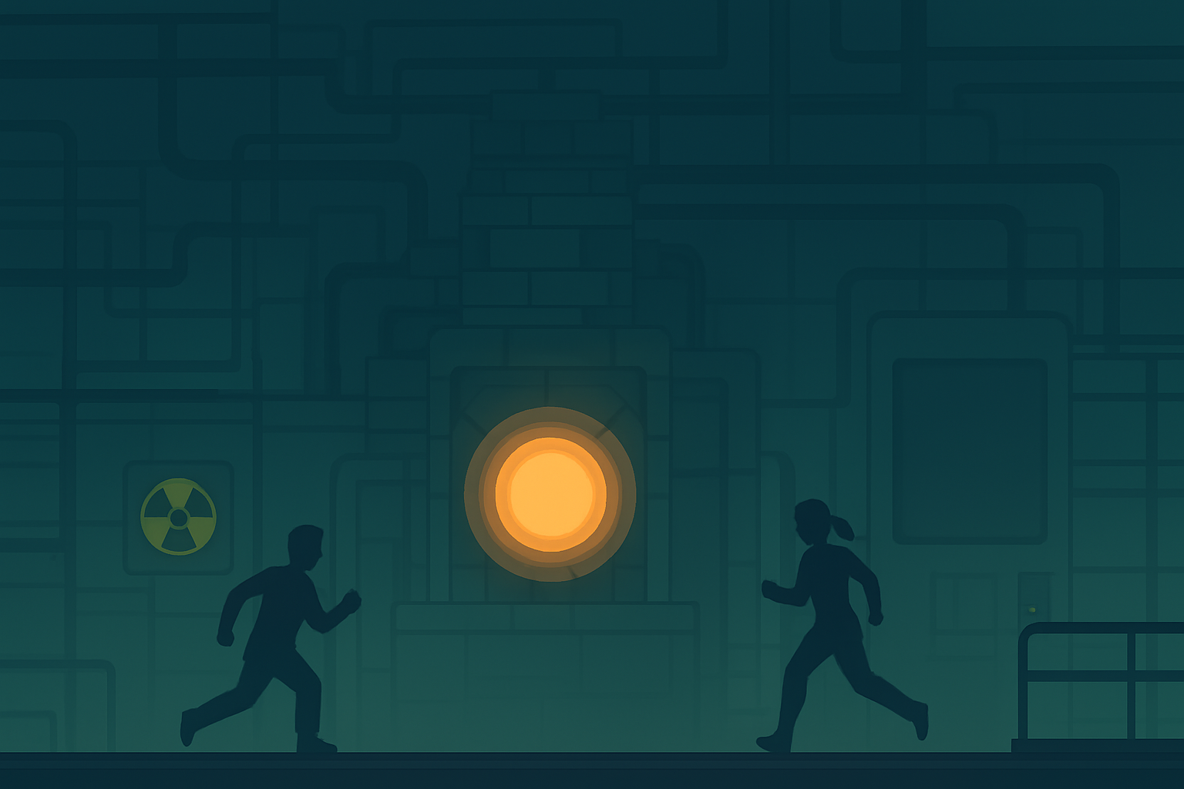

Figure 9: ChatGPT. [SA].  *Background no Text image*. (ChatGPT, 2025)

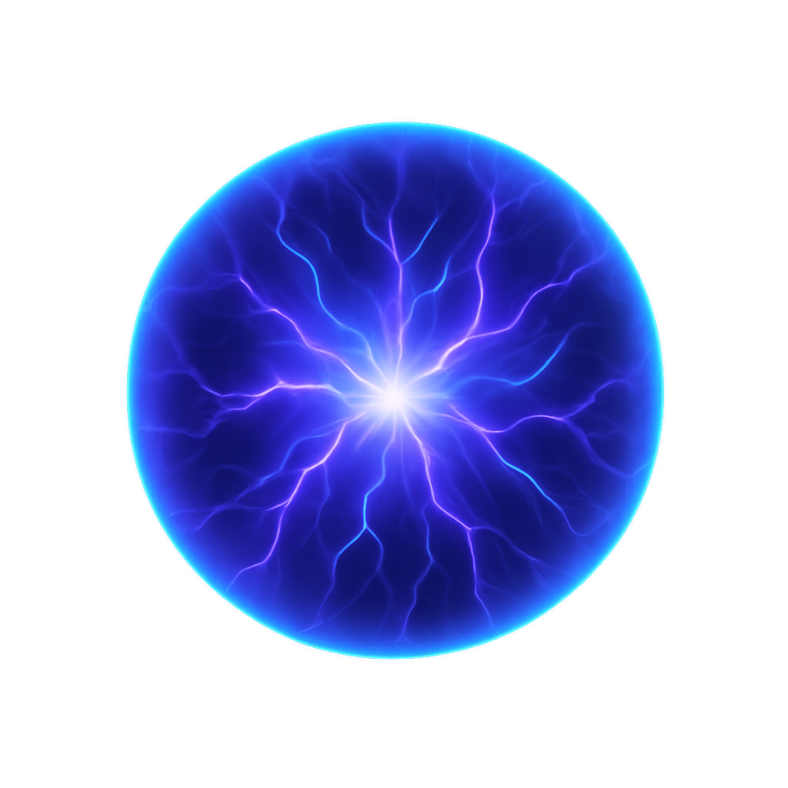

Figure 10: ChatGPT. [SA]. *Plasma Ball Sprite*. (ChatGPT, 2025)



Figure 11: ChatGPT. [SA]. *Spider Web Sprite*. (ChatGPT, 2025)

# Assets Used

16x16 Industrial Tileset By 0x72 https://0x72.itch.io/16x16-industrial-tileset

16x16+ Robot Tileset By 0x72 https://0x72.itch.io/16x16-robot-tileset

# Sound:

Electric Shock 5 Full By The-Sacha-Rush <https://freesound.org/people/The-Sacha-Rush/sounds/657817/>

FX - Laser shoot (C) By bolkmar <https://freesound.org/people/bolkmar/sounds/459615/>

HoveringObject_LAURENPOND.wav By LaurenPonder <https://freesound.org/people/LaurenPonder/sounds/635691/>

Switch - 9.wav By SpaceJoe <https://freesound.org/people/SpaceJoe/sounds/484073/>

Pressure Plate By proolsen <https://freesound.org/people/proolsen/sounds/466272/>

Collect Crystal By axilirate <https://freesound.org/people/axilirate/sounds/592346/>

Footsteps on Metal Floor By nate_asdfg <https://freesound.org/people/nate_asdfg/sounds/463811/>

low_grunt1.wav By primeval_pol... <https://freesound.org/people/primeval_polypod/sounds/156506/>

Full box drop.wav By jrhodesza <https://freesound.org/people/jrhodesza/sounds/367131/>

1 Super Fast Throwing Sound.mp3 By orginaljun <https://freesound.org/people/orginaljun/sounds/149802/>

explosion.mp3 By agaisgsbs <https://freesound.org/people/agaisgsbs/sounds/655379/>

Stick though spider web.wav By Sadiquecat <https://freesound.org/people/Sadiquecat/sounds/659428/>

Video Game Death Sound Effect By harrietniamh <https://freesound.org/people/harrietniamh/sounds/415079/>

Pickup_Gold_01.wav By LittleRobotS... <https://freesound.org/people/LittleRobotSoundFactory/sounds/270407/>

Item Sound By BeezleFM <https://freesound.org/people/BeezleFM/sounds/512138/>

Missile firing fl.mp3 By NHMWretched <https://freesound.org/people/NHMWretched/sounds/151858/>

Jump_C_09 By cabled_mess <https://freesound.org/people/cabled_mess/sounds/350899/>

075660_Cardboard Box Drop.wav By Freesound Community <https://pixabay.com/sound-effects/075660-cardboard-box-dropwav-82381/>

Cutting Power By swag1773 <https://freesound.org/people/swag1773/sounds/636578/>

Countdown Beeper By makkuzu <https://freesound.org/people/makkuzu/sounds/653956/>

Nuclear Explosion By DRAGON-STUDIO <https://pixabay.com/sound-effects/nuclear-explosion-386181/>

Demon_10.wav By LittleRobotS... <https://freesound.org/people/LittleRobotSoundFactory/sounds/316387/>

# References

ChatGPT, 2025. *Background no Text image.* [Online]   
Available at: <https://chatgpt.com>  
[Accessed 25 Stember 2025].

ChatGPT, 2025. *Crate Sprite - ChatGPT.* [Online]   
Available at: <https://chatgpt.com>  
[Accessed 25 September 2025].

ChatGPT, 2025. *Demon Sprite.* [Online]   
Available at: <https://chatgpt.com>  
[Accessed 25 Stember 2025].

ChatGPT, 2025. *Magic Barrier Sprite.* [Online]   
Available at: <https://chatgpt.com>  
[Accessed 25 Setember 2025].

ChatGPT, 2025. *Main Menu Background image.* [Online]   
Available at: <https://chatgpt.com>  
[Accessed 25 Stember 2025].

ChatGPT, 2025. *Missile Sprite.* [Online]   
Available at: <https://chatgpt.com>  
[Accessed 25 Stember 2025].

ChatGPT, 2025. *Nuclear Reactor Rods Sprite - ChatGPT.* [Online]   
Available at: <https://chatgpt.com>  
[Accessed 25 Setember 2025].

ChatGPT, 2025. *Nuclear Reactor Sprite - ChatGPT.* [Online]   
Available at: <https://chatgpt.com>  
[Accessed 25 September 2025].

ChatGPT, 2025. *Plasma Ball Sprite.* [Online]   
Available at: <https://chatgpt.com>  
[Accessed 25 Stember 2025].

ChatGPT, 2025. *Sabotage Coin Sprite.* [Online]   
Available at: <https://chatgpt.com>  
[Accessed 25 Stember 2025].

ChatGPT, 2025. *Spider Web Sprite.* [Online]   
Available at: <https://chatgpt.com>  
[Accessed 25 Stember 2025].

List of Figures:

Figure 1: ChatGPT. [SA]. *Crate Sprite*.

Figure 2: ChatGPT. [SA]. *Nuclear Reactor Sprite*.

Figure 3: ChatGPT. [SA]. *Magic Barrier Sprite*.

Figure 4: ChatGPT. [SA]. *Nuclear Reactor Rods Sprite*.

Figure 5: ChatGPT. [SA]. *Main Menu Background image*.

Figure 6: ChatGPT. [SA]. *Demon Sprite*.

Figure 7: ChatGPT. [SA]. *Missile Sprite*.

Figure 8: ChatGPT. [SA]. *Sabotage Coin Sprite*.

Figure 9: ChatGPT. [SA]. *Background no Text image*.

Figure 10: ChatGPT. [SA]. *Plasma Ball Sprite*.

Figure 11: ChatGPT. [SA]. *Spider Web Sprite*.